Human Biology – General Year 12 2019

## Task 2 – Unit 3

**Assessment Type:** Test **MARKING KEY**

**Weighting: 7.5%**

***MULTIPLE CHOICE SECTION [5 MARKS]***

|  |  |
| --- | --- |
| **1** | **C** |
| **2** | **B** |
| **3** | **C** |
| **4** | **C** |
| **5** | **B** |

***SHORT ANSWER SECTION [47 MARKS]***

1. Describe the importance of the skeleton in the human body [5 marks]

|  |  |
| --- | --- |
| 1 mark each for:   * Support the body – gives the body shape/not a puddle * Protect internal organs – is on the outside of organs to protect from harmful blows * Produce red blood cells – red marrow in epiphysis makes red blood cella * Movement of the body – is connected to muscles to bring about body movement * Storage - of minerals (calcium/phosphate) and/or fat | **1-5** |

1. Look at the human skeleton below.
2. identify the following bones: [3 marks]

|  |  |
| --- | --- |
| **1 mark each for:**  a: Scapula  b: vertebrae   * c: Radius | **1-3** |

1. Using a pencil or texta, colour the axial skeleton [1 mark]

|  |  |
| --- | --- |
| * **Circles the skull, vertebrae and ribs** | **1** |

1. Label one example of a long bone, a short bone and an irregular bone [3 marks]

|  |  |
| --- | --- |
| * Labels a long bone accurately (femur, radius, ulna, clavicle, tibia or fibula) | **1** |
| * Labels a short bone accurately (tarsals, carpals, etc) | **1** |
| * Labels an irregular bone accurately (skull, mandible, etc) | **1** |

1. The ends of bones in a synovial joint never touch. If they did, moving would be very painful. What fluid in the joint helps keep the bones from touching? [1 mark]

|  |  |
| --- | --- |
| Synovial Fluid | **1** |

1. Explain why a diet with milk or dairy products and sensible sun exposure are important for improving bone health in children. [4 marks]

|  |  |
| --- | --- |
| **Description** | **Mark** |
| **Milk and dairy products**   * Provides calcium * Builds the matrix that gives strengths | 1-2 |
| **Sensible sun exposure**   * UV radiation / sun causes / stimulates formation of vitamin D * Vitamin D increases the body’s ability to absorb calcium for bone growth and development | 1-2 |

1. The body has several different types of joints, each with specific features and functions: Complete the following table as a summary of these different joints. [6 marks]

|  |  |  |
| --- | --- | --- |
| **LOCATION** | **JOINT TYPE** | **ONE MOVEMENT PRODUCED** |
| Elbow | Synovial (1/2)  Hinge (1/2) | Flexion or extension (1/2) |
| Shoulder | Synovial (1/2)  Ball and Socket (1/2) | Circumduction (1/2)  *Could also say extension, flexion, abduction or adduction* |
| Vertebrae | Cartilaginous (1/2) | Little movement (1/2) |
| Skull | Fixed/Fibrous/immovable (1/2) | No movement (1/2) |
| Neck | Pivot(1/2) | Rotation(1/2) |

1. Babies are born with roughly 300 bones. Describe why adults only have 206 bones. [3 marks]

|  |  |
| --- | --- |
| **Description** | **Mark** |
| * Babies are born with bones that have not fused * As the age, many of these bones fuse together/bones combine/smaller bones join to make big bones * Gives an example (e.g, the skull) | 1-3 |

1. The diagram below shows a synovial joint in the human body. Name the structure and state the function of the structures indicated. [6 marks]

|  |  |
| --- | --- |
| **Description** | **Mark** |
| Name (1) and Function (1) |  |
| A:   * articular cartilage / cartilage * prevents friction / smooth movement/ protects epiphyses/stops epiphyses from grinding together | 1-2 |
| B:   * Ligament * attaches bone to bone / joint movement / holds joint together/attaches articulating bones | 1-2 |
| C:   * cavity with synovial fluid / synovial fluid / cavity * cushions against impact / reduces friction / nutrients / cells clean out joint /shock absorber | 1-2 |

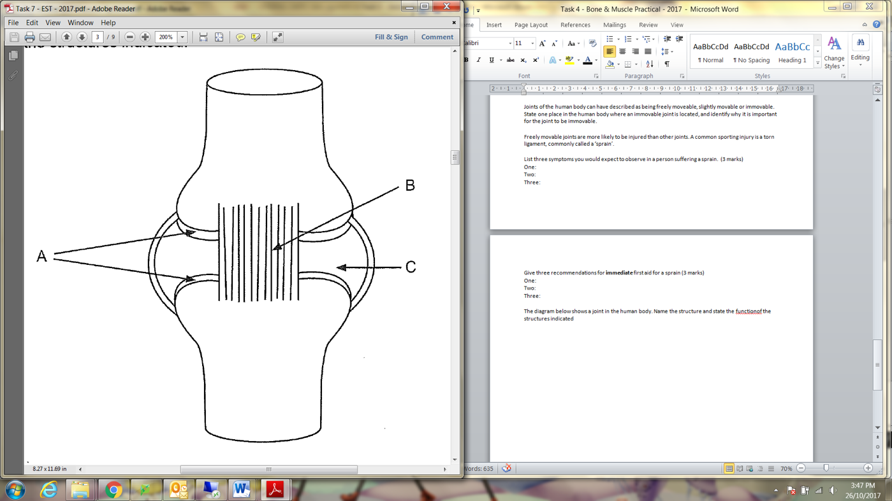

1. During a game of soccer, Justin’s ankle became hyperextended. He felt pain, his ankle began to swell and he was unable to place weight on his foot. After two-weeks, his ankle had still not healed.
   1. State the name of the injury Justin sustained: Sprained Ankle/Sprain [1 mark]
   2. Describe the structure that Justin had injured. [2 marks]

|  |  |
| --- | --- |
| **Description** | **Mark** |
| Any two of:   * It is a ligament * It is made of connective tissue * It connects bone to bones | 1-2 |

* 1. Explain why this body part will take longer to heal than muscle or bone [2marks]

|  |  |
| --- | --- |
| **Description** | **Mark** |
| * It has no blood vessels/direct blood supply * Nutrients needed to heal have to diffuse through the ligament, which takes a long time | 1-2 |

* 1. In order for Justin’s ankle to heal more rapidly, he should have been given immediate first aid on the soccer field. State three recommendations for immediate first aid of this injury. [3 marks]

|  |  |
| --- | --- |
| **Description** | **Mark** |
| Answers could include: |  |
| * R - Stop exercise and rest the injured area / remove weight * I - Use of icepacks * C - Compress / bandage / strap * E - Elevate the injured area about heart height * If they only say RICE , no mark. | 1-3 |

1. Observe the diagram of a long-bone below. Label the: [3 marks]
   1. 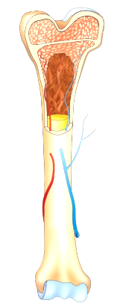Epiphyseal line
   2. Spongy bone
   3. Diaphysis
2. Describe the difference between compact bone and spongy bone in terms of structure and function [4 marks]

|  |  |
| --- | --- |
| **Description** | **Mark** |
| Compact bone |  |
| * STRUCTURE: Made of osteons/ring structure/cylinders that run parallel to each other * FUNCTION: is weight-bearing bone/supports body weight | **1-2** |
| Spongy bone |  |
| * STRUCTURE: Made of trabeculae/irregular bony matrix/porous * FUNCTION: stores red bone marrow/can take weight from many angles but not as much weight as compact bone | **1-2** |